NASPA Executive Board Committee Meeting
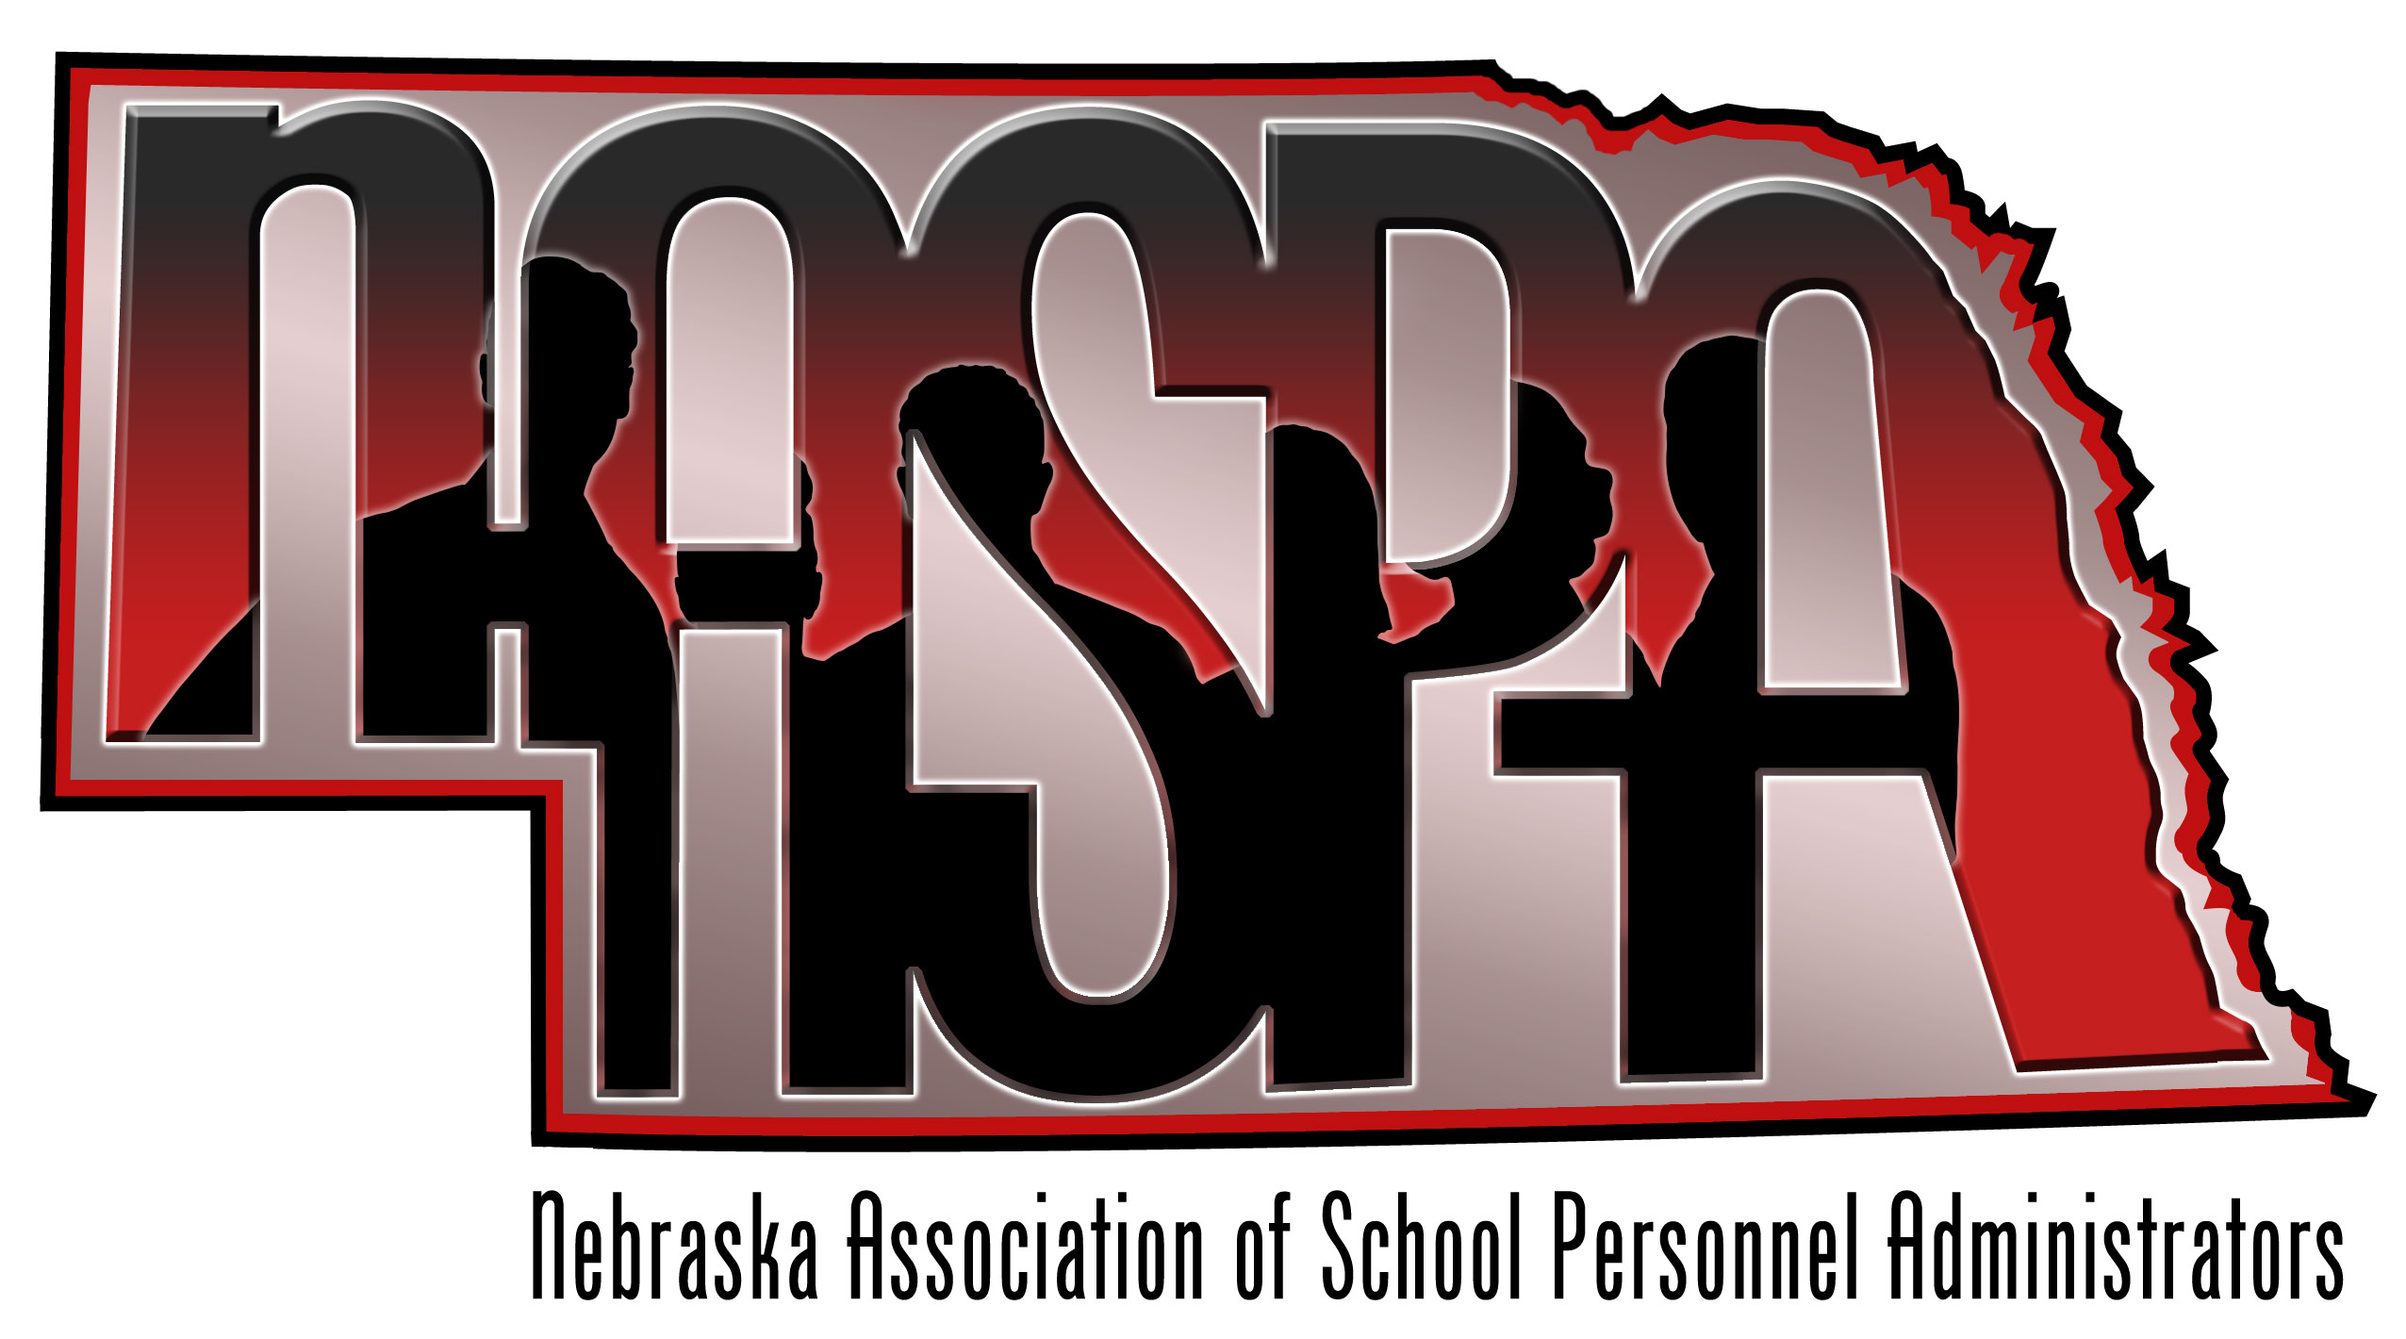
April 12, 2012

SUMMARY OF AGENDA TOPICS

- update on 501c3 status
This ongoing process continues – no news is good news!!

- membership
Dues will remain at $25 and will continue to be a part of the NCSA membership form and renewal information.
The NASBO program will include an advertisement for NASPA membership.

- Kelly Coash-Johnson
The group discussed upcoming professional development offerings. Renee Hyde and Eric Weber will represent NASPA at the NASBO conference.

- Treasurer/Secretary
Norma Hledik has resigned her position as Secretary/Treasurer immediately as she will be having hip surgery followed by a lengthy recovery process. Norma has served NASPA in this capacity for several years and has done an outstanding job!

It was decided that this would be a natural time to transition our finances to the guidance of NCSA. They will maintain our account independently and manage the day to day financial needs of the organization (which is very little).

The Executive Board would like to nominate Jenise Straight for the official position of Secretary/Treasurer. Jenise is the Director of Special Services for ESU#9 in Hastings and has been a member of NASPA for several years. She currently serves as a Member-At-Large on the Executive Board. If elected, Jenise would serve in both roles through the June 2012 Retreat. Please see the attached email for voting procedures.

- NDE Certification changes
A discussion was held on changes to Certification and it was suggested that Kevin Peters be invited to speak at the Summer Retreat.

We also briefly discussed changes to SPED certification. These potential changes are attached to the email.

- Frameworks Committee update
The Steering Committee formed by NDE will meet for the first time next week.

- future meetings
NASPA Conference – June 28-29, 2012 in Nebraska City SAVE THE DATE!!!
Registration materials will be coming out within the next month.
1) vendors – a discussion of vendors and process was held
2)agenda – Kelly is working to finalize the agenda
3)door prizes – there will be prizes for everyone

Tentative schedule:
Thursday, June 28th
10:00 am Executive Board Committee Meeting
12:30 pm registration and check-in
1:00 pm – 5:00 pm Conference sessions

Friday, June 29th
8:30 am – 12:00 pm Conference sessions (to include a Business Meeting)
12:00 pm Conference concludes

