NASPA Executive Board Committee Meeting
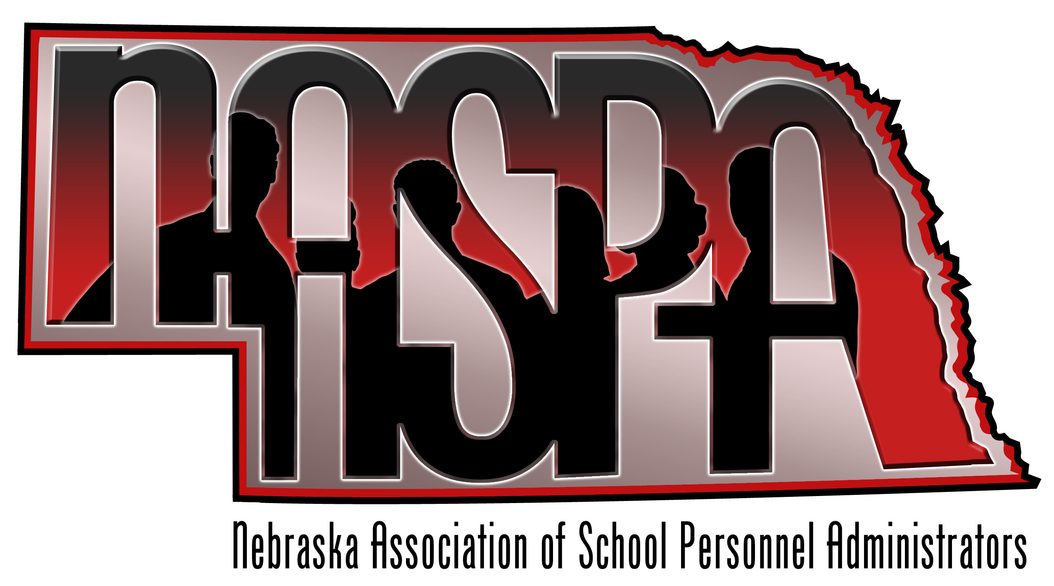
November 8, 2012

AGENDA Minutes
Attendees: Kevin Chick, Kay Byers, Sharra Smith, Jenise Straight, Erin Heineman, Nancy Biggs, Renee Hyde, Amy Poggenklass

Before the meeting, a card from Nancy Whitney was shared with the group thanking NASPA for her retirement gift.

- Website
    - Currently is not operational, need to get up and running and functional
    - -Possible listserv, social media presence, goals for this year?
Our website is currently under construction and not available. Amy stated that NCSA is working on our site and hope to have it up soon. We discussed whether or not to create and maintain our own site using weebly, a Wiki, or something else. If any of our members have ideas on easy to use sites to create and maintain our own site, please let me know. If we created our own site, we would still link it to the NCSA site.
  - future plans for the website, which would include (Some items from last year):
    - -Executive Board contact info √
    - -Minutes from the annual conference
    - -Save the Date for this year’s conference
    - -List of current membership to include name/title/district
    - -Conference Agendas from previous conferences
    - -Link to AASPA website
    - -Constitution & By-Laws
    - -List of presentations members would be willing to present at various conferences
    - -NASPA email
    - -Link to Social Media (Twitter, Facebook, LinkedIn?)

- Nebraska Teacher & Principal Performance Frameworks
- Letter from NASPA
- Attendance at State Board Meetings
We reviewed the letter we sent to Dr. Breed and the State Board of Education that supports the recommendation to approve the Nebraska Teacher and Principal Frameworks (Letter is attached in this e-mail). Renee Jacobson attended the NASPA board meeting to discuss/answer questions. Renee, Sharra Smith, and Kevin Chick attended the State Board of Education work session on Thursday, November 8th to field any questions about our position on the recommendation. The Board seemed in favor of approving the recommendations and I believe they passed the recommendations on November 9th.

- Organizational Structure of NASPA
- Term of executive board
- Explore creating regions
- Recruitment of membership from smaller districts
- Possible second NASPA conference…..HR support Staff?
We discussed the current structure of our Executive Board and discussed possibly lengthening the terms of the board members to two years for the President-Elect and President. This added stability will strengthen the organization as a whole and allow the president to get more accomplished during his/her term. We will discuss this again at our next meeting. Any changes would have to be approved by the membership as this would constitute a change to the by-laws.

- Possible presentation topics for 12-13
- How many
- What conferences do we target?
Possibly NASBO in April, Admin Days?

Hosting another conference during the school year was discussed in addition to our Summer Retreat in June. We discussed having an HR Conference for Support Staff. We realized that this presents challenges as to whether Districts will allow hourly staff to attend. Amy suggested that we think about hosting a webinar conference where support staff from around the state could participate via the web. If any of you have any ideas for a webinar or are interested in presenting a webinar, please let me know. We will discuss this topic again at our February meeting.

- MVSPA – December 13-14-Kansas City
- Possible NASPA presentation?

Kay Byars was going to contact the President of the Kansas group to see if they still needed presenters for the MVSPA conference in December. If any of you have presentation topics you wish to share let me know. We hope to see everyone there!

- NASPA Conference – June 27-28, 2012 in Nebraska City
Reservations are made
Save the date in March
Send reservation materials in May
Program ideas???
Door prizes – budget??
We discussed some presentation ideas such as, “Using Twitter to Recruit and Promote”. Please send any other ideas or suggestions for presentation topics for the NASPA Retreat to Kevin Chick.

- Future Executive Board Meetings
February 7th
April 11th
Meet at the NCSA Building at noon – networking lunch followed by the board meeting.

