NASPA Executive Board Committee Meeting
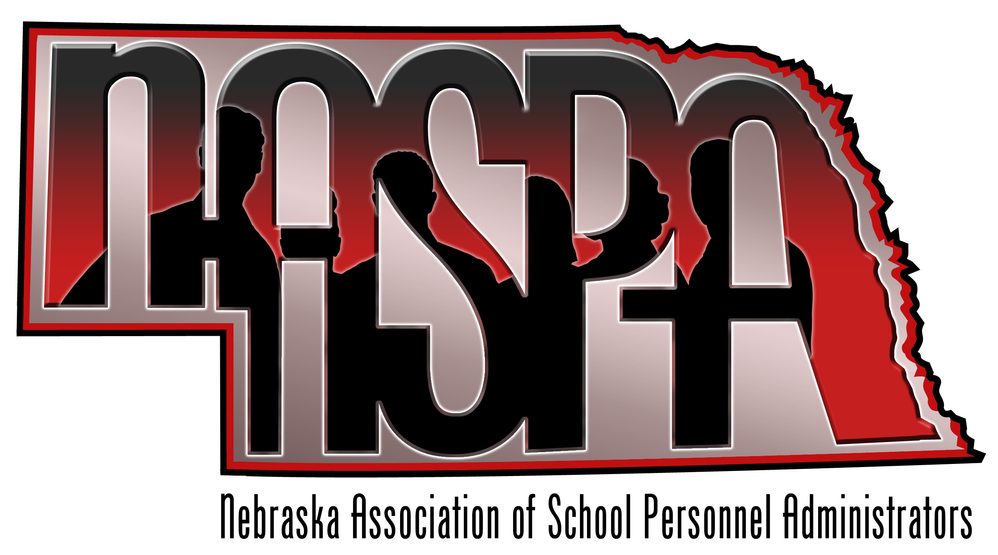
September 12, 2013

AGENDA

- Welcome to new board members and introductions

- What is big in your District right now?

- AASPA - San Antonio

- MVSPA – Lincoln Hosting. Possible presentations from our group. What other needs?

- Annual NASPA retreat debrief – General thoughts, what should we be planning for this June?

- Budget Update – Amy

- NCSA/legislative Update – Amy will present information on behalf of Mike and Dan

- Future Meetings/ Dates
October 1-4 – AASPA National Conference-San Antonio
November 14 – NASPA Executive Board Meeting
December 5 & 6 – MVSPA Conference – Lincoln
February 13 - NASPA Executive Board Meeting
April 10 - NASPA Executive Board Meeting

