NASPA Executive Board Committee Meeting
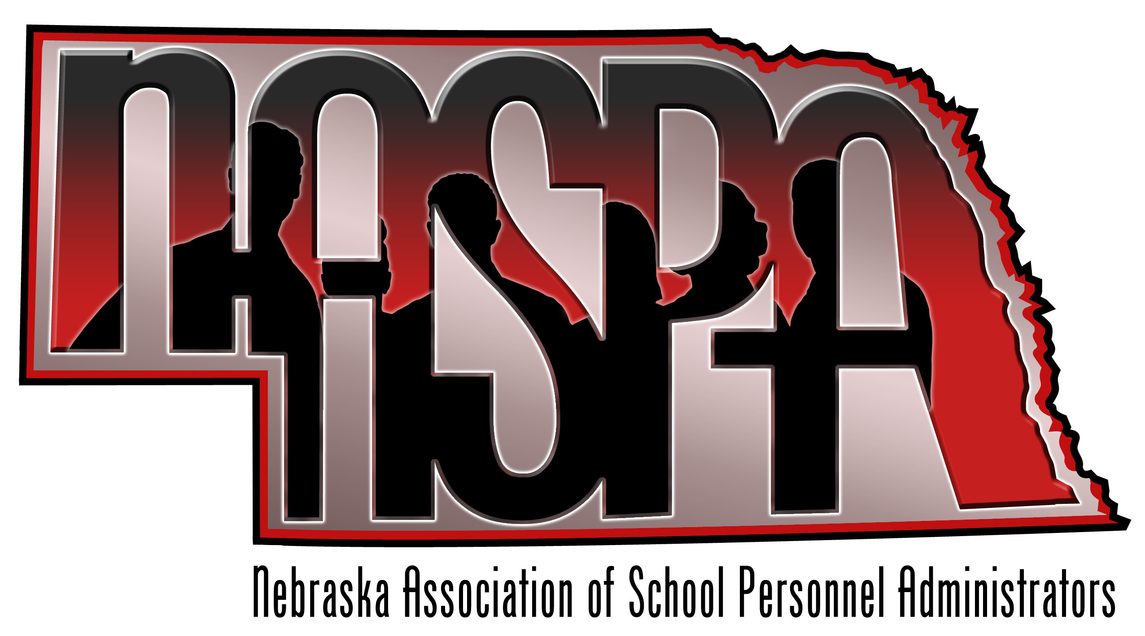
February 7, 2013

AGENDA

- Website-Not much progress on this one. Listed below is what we discussed in November.
    - Currently is not operational, need to get up and running and functional
    - -Possible listserv, social media presence, goals for this year?

- Nebraska Teacher & Principal Performance Frameworks
- Any Updates?

- Organizational Structure of NASPA-We discussed this in November…what do we need to do to change current terms? Present proposal to membership?
- Term of executive board
- Recruitment of membership from smaller districts
- Possible second NASPA conference…..HR supports Staff?

- Presentations topics for 12-13
- 3-4 NASPA presentation at NCSA Education Forum (February 5)
- What other conferences do we target?
- HR support staff webinar in Fall of 13-14?

- NASPA Conference – June 27-28, 2012 in Nebraska City
Reservations are made
Save the date in March
Send reservation materials in May
Program ideas???
Door prizes – budget??
- Legislative Update
- Summary of NCSA position on bills
- Discussion on bills, NASPA support, opposition?

- Future Executive Board Meetings
April 11th
Meet at the NCSA Building at noon – networking lunch followed by the board meeting.

